SECURITY SERVICES
Security Card and Parking Permit Application Form

INSTRUCTIONS:

The following persons are authorised to request a security card for an Applicant:

Category | Applicant
Caregivers | Caregivers working at SJG Midland Private Hospital or SJGHC caregivers working regularly at SJG Midland Private Hospital
Volunteers | Volunteers working at SJG Midland Private Hospital
Doctors | Medical practitioners accredited at SJG Midland Private Hospital
Contractors | Contractors working at SJG Midland Private Hospital, but not based at the hospital
Tenants / Providers | Tenants and service providers located at SJG Midland Private Hospital

The Applicant (you) needs to complete all fields of this form and attach a suitable photo of the Applicant in the ATTACH PHOTO HERE field. Once completed, please send the form to the respective security service (hyperlinks are at the bottom of the form).

Before we print the card, we must confirm the eligibility of the Applicant with data we receive from HR or similar sources. If the Applicant is not yet registered on the required databases (HR, Credentialing etc), there can be delays before the card can be printed.

The security card will automatically give the Applicant the access required for their role and department. If access to additional areas is required then please submit a MPV_SEC_003 Additional Security Access Request form after you have collected your card.

Once the card has been printed (usually within 1 business day), we will notify you via email including where the card can be picked up from. The Applicant (you) will need one form of photo identification (e.g. driver’s license, passport, another existing SJOG identification card) to pick up the card.

CONDITIONS FOR SECURITY CARD:

The Authorised Requestor, by submitting this form, confirms that they are the Authorised Requestor for the Applicant and that they have informed the Applicant of the following:
- Caregiver issued security cards remain the property of SJGHC and it has to be returned at the end of their employment.
- That the care and safekeeping of the security card is their responsibility. Any loss or severe damage to the security card needs to be reported to the respective security service immediately.
- That they cannot deface the card in anyway, including obscuring the name/photo or placing stickers on the card.
- That any replacement of their security card due to loss, defacing or severe damage (other than reasonably occurred while performing their duties) may incur a replacement fee [currently $20.00, subject to change].
- That security cards must be clearly visible while on duty.

CONDITIONS FOR STAFF PARKING:

- Onsite parking will be provided for SJG Midland Private staff.
- Vehicles may only park in the areas designated for staff. To enter and exit the
Designated areas the boom gate has numberplate recognition, or you can swipe your security card at the boom gates for entry.
- The registration number of any vehicle used temporarily in place of authorised
Vehicle must be made known to the Security Department.
- In the event of a permanent change of vehicle, notify Security Department of the
replacement vehicle details.
- The car parks are regularly patrolled and monitored. Any parking violations will be
acted upon. Continual breaches of car parking regulations could result in your
parking privileges being removed along with suitable disciplinary action being taken.
- NOTE: The hospital does not accept liability for any loss or damage arising from the use of
its parking privileges. Care should be taken to avoid leaving cars unlocked or items of
value in vehicles.

APPLICANT DETAILS (who needs the card)
First Name | Click here to enter text. | Note: All fields must be complete or application will be rejected.  ATTACH PHOTO HERE    The photo must comply with the minimum requirements mentioned in the Acceptable Identification Photo Requirements.  Unacceptable photos may result in delays to get your card printed.
Preferred Name | Click here to enter text.
Last Name | Click here to enter text.
Position Title  (Dr, Volunteer, VMO, Nurse, Admin etc.) | Click here to enter text.
Employee Number  (SJGHC Caregivers only) | Click here to enter text.
Ward/Department  (SJGHC Caregivers only) | Click here to enter text.
Email address | Click here to enter text.
Mobile Number | Click here to enter text.
Vehicle Registration Number | Click here to enter text.
Vehicle Make & Model | Click here to enter text.
Vehicle Colour | Click here to enter text.
Manager Name  (not applicable for Doctors) | Click here to enter text.
Manager Email  (not applicable for Doctors) | Click here to enter text.

 | Save this form
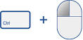 | Press CTRL and Click on the hyperlink below
 | - Email for Midland Private Security (mp.security@sjog.org.au)
 | Attach the form to email
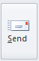 | Press SEND
DO NOT PRINT THIS FORM. We need the original electronic version to be able to process your card application.
ACCEPTABLE IDENTIFICATION PHOTO REQUIREMENTS

Requirement | Example
- Plain background (white, light grey, light beige are acceptable) – no busy backgrounds  - Generally head and shoulders only, but we can crop a little as part of the upload | 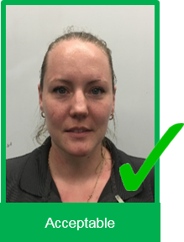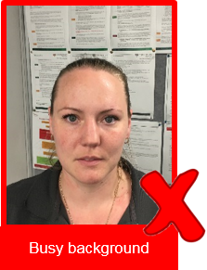
- No head covering unless for religious reasons (e.g. no theatre caps)  - No sun glasses etc  - Facial features visible and recognisable | 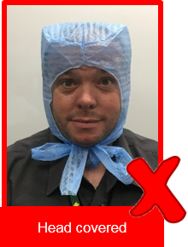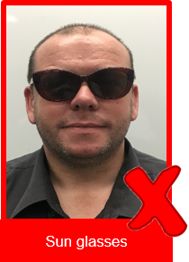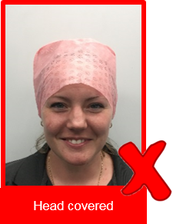
- Front on, not side ways | 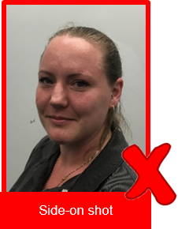
- Contrast clear, not over or under exposed  - Sharp - not blurry, not distorted  - Resolution sufficient for printing (most smartphones will easily meet this requirement) | 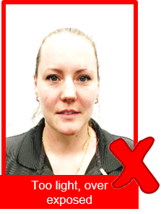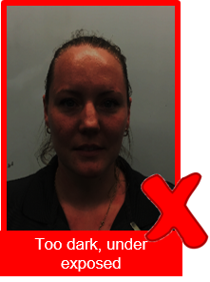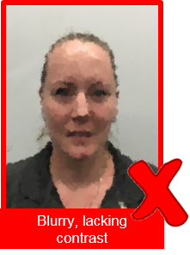
- No older than 1 year
- Smiling permitted

Unacceptable photos may result in delays getting your card printed.

SECURITY OFFICE TO COMPLETE

OFFICER INTITIALS | Click here to enter text.
PHOTO CHECKED AND ACCPETABLE | ☐
CAREGIVER ENTERED ON ACCESS CONTROL SYSTEM? | ☐
REQUESTOR EMAILED? | ☐
CARD NUMBER ISSUED | Click here to enter text.
DATE COMPLETED | Click here to enter a date.
DOCUMENT ANY ISSUES OR INTERACTIONS WITH THE REQUESTORS

Save the completed form on SharePoint in the respective security folder.

